**DAILY ONLINE ACTIVITIES SUMMARY**

|  |  |  |  |  |  |  |  |  |
| --- | --- | --- | --- | --- | --- | --- | --- | --- |
| **Date:** | **2-06-2020** | | | | | **Name:** | **Pavana P** | |
| **Sem & Sec** | **6A** | | | | | **USN:** | **4AL17CS057** | |
| **Online Test Summary** | | | | | | | | |
| **Subject** | | **CGV** | | | | | | |
| **Max. Marks** | | **30** | | **Score** | | | **30** | |
| **Certification Course Summary** | | | | | | | | |
| **Course** | **RPA.** | | | | | | | |
| **Certificate Provider** | | | Guvi | | **Duration** | | | 3 hours |
| **Coding Challenges** | | | | | | | | |
| **Problem Statement:**   1. Python program to return a list containing first and last element using list slicing method 2. Write a program to check if given linked list has a loop or not. 3. Given an array of positive integers. Write a C Program to find inversion count of array. | | | | | | | | |
| **Status: Completed** | | | | | | | | |
| **Uploaded the report in Github** | | | | | **YES** | | | |
| **If yes Repository name** | | | | | **DAILY STATUS** | | | |
| **Uploaded the report in slack** | | | | | **YES** | | | |

.

**Online Test :**

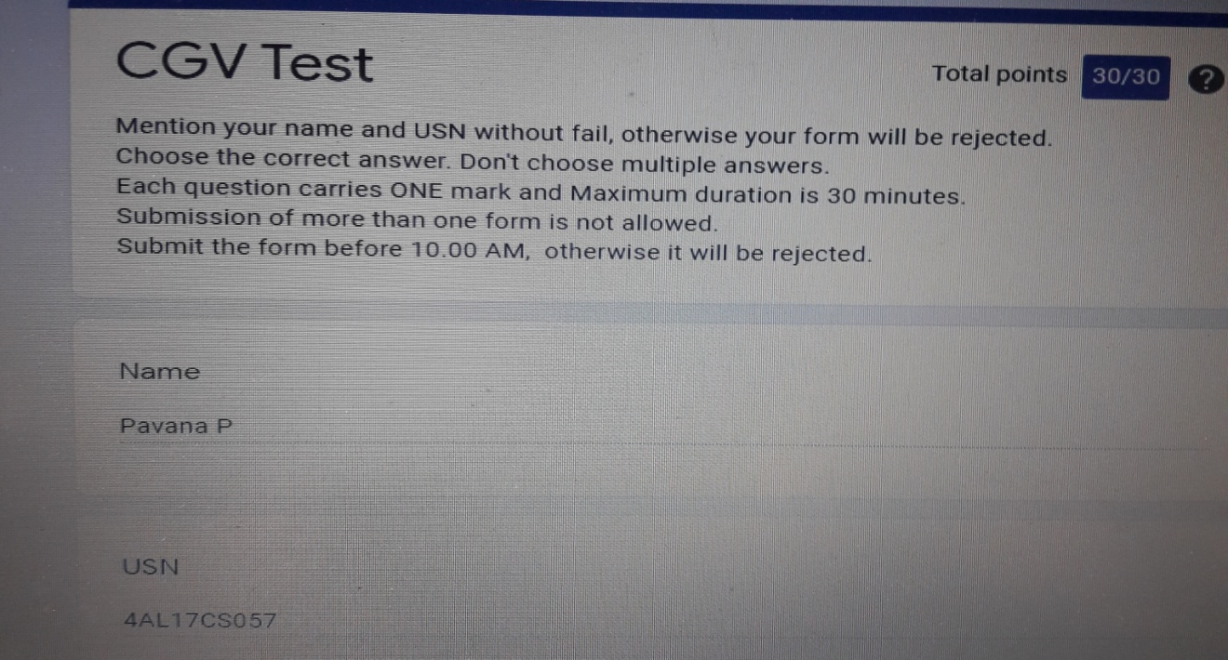Subject:-CGV

**Certification Course Details:**

**Robotic Process Automation:**

Today I have completed the Step into Robotic Process automation Course

.

.

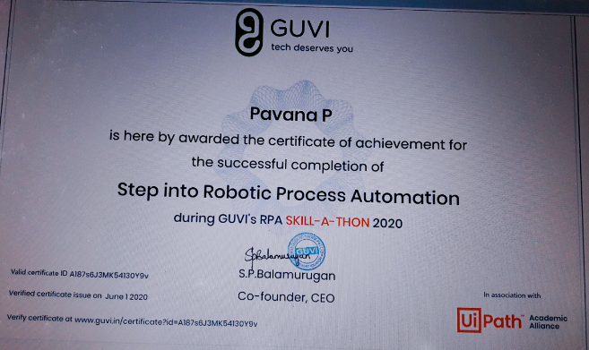

**Coding Challenges Details:**

**https://github.com/pavana-p-kulal/DAILY-STATUS/tree/master/2-6-20/Online%20Coding**